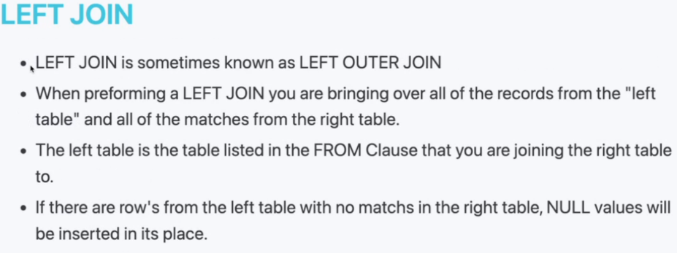Week 8

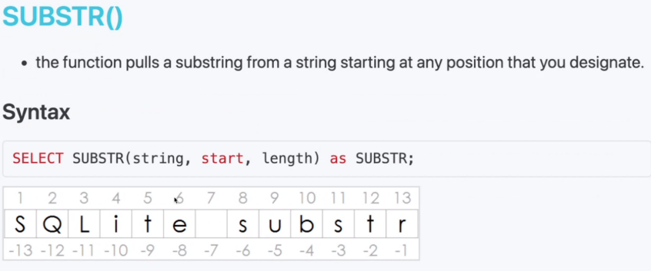Inner join only returns matches while left join returns everything and will return null values

